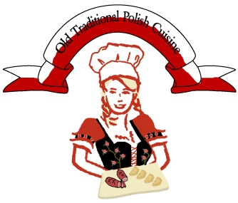

OLD TRADITIONAL POLISH CUISINE CATERING MENU

KIELBASA (served with roasted peppers, pickles, mustard, and Grandma's bread):
small platter (10-12pp): $125
medium platter (15-20pp): $175
large platter (25-30pp): $260

GRILLED CHICKEN
marinated in herbs & spices
served with carrot garnish
$7 per person (6 person minimum)

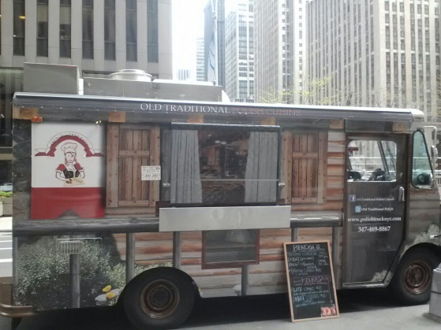
PIEROGI (all pierogi served with fried onions)

POTATO & CHEESE servings:
extra small: $100 extra small: 5-8p
small platter: $145 small: 10-12 p
medium: $260 medium: 15-22p
large: $390 large: 25-30p

MEAT SPINACH & CHEESE
extra small: $105 extra small: $105
small: $155 small: $155
medium: $270 medium: $270
large: $400 large: $400

KRAUT & MUSHROOM: CABBAGE:
extra small: $105 extra small: $105
small: $145 small: $145
medium: $260 medium: $260
large: $390 large: $390

POLISH VEGETABLE STEW (vegan) -
(Leczo in Polish) – Zucchini, tomato, onion, garlic, + peppers @$12.95/pp (6 person minimum)

Vegetarian BIGOS (Hunter Stew) – great addition to Kielbasa!
Cabbage, mushrooms, carrots, onions, plums, sauerkraut, tomato concentrate – Stew @$12.95/pp

SALADS
Creamy Leek Salad (leek, celery, apple in a mild mayo dressing)*goes perfectly with grilled kielbasa! (only one size platter available): $80

Pickle Salad
only one size platter available: $80

Traditional Polish Vegetable Salad
$8.95pp (6 person minimum)
(potato, carrots, peas, celery, pickles, eggs, parsley, non-fat mayo, salt, pepper)

Layered Grilled Chicken Salad
$10.75 pp (6 person minimum)
(Chinese cabbage, red peppers, corn, onion, pickled cucumber, seasoned grilled chicken, cheese, non-fat mayo, ketchup)

TRADITIONAL PLATES AND SANDWICHES
Traditional Polish-Style Sandwiches (only served for breakfast)
$10pp (8 person minimum)
Array of home-style ham, stuffed veal breast, smoked & cured pork loin, roasted chicken breast, roasted port, home-style bacon, served differently and dressed with fresh radish, tomato, iceberg, romaine, or bibb lettuce, mustard, mayo, marinated red peppers, dill pickles, horseradish, red beets, etc. All sandwiches are different and dressed accordingly to chef’s vision.

Traditional Polish Plate (can be served for breakfast or lunch)
$11pp (6 person minimum)
Array of traditional cold-cuts served on a platter. Different types of bread and rolls are served on the side.

Traditional Polish Cheese Plate (can be served for breakfast or lunch)
$7.50pp (6 person minimum)
Array of traditional cheeses served on a platter. Different types of bread and rolls are served on the side.

Traditional Farmer’s Cheese Deluxe (can be served for breakfast or lunch)
$6.75pp (6 person minimum)
Classic farmer’s cheese mixed with fresh radish, fresh cucumber, fresh scallion, salt, pepper.
Served with different types of rolls on the side.

DESSERTS
(desserts are per person) – 6 person minimum per order

Paczki (Polish Style donuts): $3
Poppyseed cake $3
Babka (vanilla/chocolate) $3
mixed plate $3 per person (several different traditional pastries offered)

JUICE
Traditional Juice $3.50pp (6 person minimum)
Choice of: Black Currant, Red Currant, Apple Mint, Apple Peach

Email us: OldTraditionalPolishCuisine@yahoo.com for any catering inquiries

We also do private events!

Have a budget? email us and we can see what we can do!
*please note that tax will be added to all orders

PIEROGI: 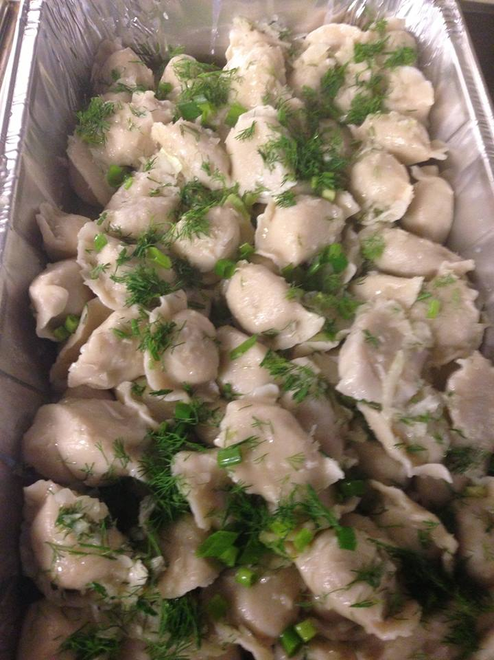
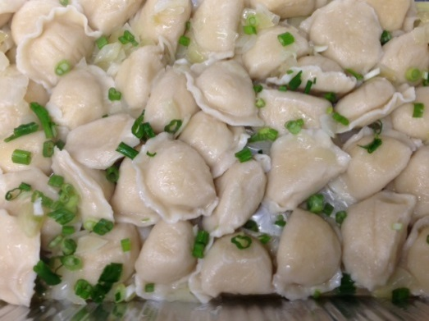
VEGGIE STEW:
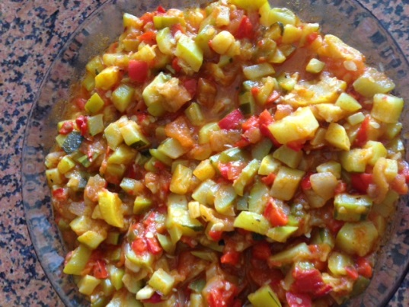

KIELBASA:
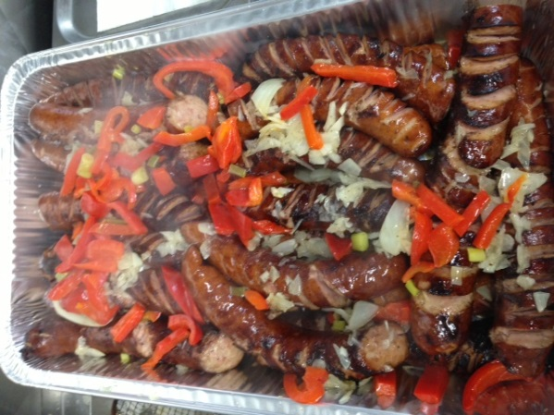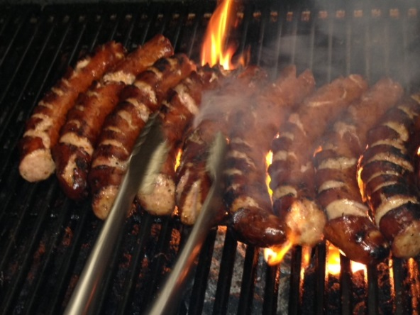
GRILLED CHICKEN: 